# Supplementary File 1

# Supplementary Discussion

# Validity of the Michaelis-Menten formalism for GTPases

Michaelis-Menten formalisms have been used for multiple GTPases including Ran1, Ras2, or Rap3. Historically there have been many attempts to formalize the conditions under which the Michaelis-Menten equation to describe enzyme kinetics are valid (as reviewed by Schnell4). These conditions have converged on the steady-state approximation or more generally, on the reactant stationary assumption. The formal condition for steady-state approximation is that t[ES] (the time it takes for the steady-state levels of [ES] complex to accumulate) is substantially shorter than t[S] (the time where [S] changes significantly). The formal condition for reactant stationary assumption is that [S] ≈ [S0] during initial build-up of [ES].

The formal condition for validity of the Michaelis-Menten equation can be expressed as:

$\frac{{[E}_{0}]}{K_{m}+ {[S}_{0}]} ≪\left(1+ \frac{K}{K_{S}}\right)\left(1+ \frac{{[S}_{0}]}{K_{m}}\right)$,

where $K= \frac{k_{cat}}{k_{on}}$ and $K_{S}= \frac{k_{off}}{k_{on}}$, and koff and kon are the rates of [ES] complex formation5.

The measured dissociation constant, $K_{S}= \frac{k_{off}}{k_{on}}$, for the formation of the Ran:GDP:RCC1 complex from Ran:GDP and RCC1, where RCC1 is the human RanGEF, is 0.9 μM6, which is approximately the same as the Km value obtained for the GEF-mediated nucleotide exchange for both *S. cerevisiae* Gsp1 and human Ran. That means than $K ≪ K_{S}$, which means the condition for validity of the Michaelis-Menten equation can be approximated as $\frac{{[E}_{0}]}{K_{m}+ {[S}_{0}]} ≪\left(1+ \frac{{[S}_{0}]}{K_{m}}\right)$, and since in all of our GEF experiments both [E0] = 5-20 nM << Km and [E0] << [S0], the conditions holds true for the entire range of [S0] values, both below and above the Km.

As $\frac{K}{K_{S}}$ can also be expressed as $\frac{k_{cat}}{k_{off}}$, and the measured koff of human Ran:GTP and RanGAP from *S. pombe* is estimated to be around 150 s-1, while our measured kcat values range from 1 to 10 s-1, as above, $\frac{K}{K_{S}} ≪1$ the assumption of steady-state holds true as long as [E0] << Km and [E0] << [S0], which is the case as we used 1-5 nM GAP in all of our experiments.

## Potential caveats associated with using the GAP (Rna1) from *S. pombe*

All of our GAP-mediated GTP hydrolysis kinetics experiments used the wild type and mutant Gsp1 from *S. cerevisiae*, but Rna1 GAP from *S. pombe*. We chose to use the Rna1 ortholog from *S. pombe* as *S. cerevisiae* Rna1 formed soluble aggregates after purification, and *S. pombe* Rna1 was the only RanGAP for which there was a structure in complex with Ran (PDB IDs: 1k5d and 1k5g). While there could be slight differences between the kinetic parameters of *S. pombe* and *S. cerevisiae* GAP Rna1 acting on Gsp1, we do not believe these differences would significantly affect our conclusions, based on the following considerations:

1.) **Sequence conservation between *S. cerevisiae* and *S. pombe* Rna1.** A sequence alignment between *S. cerevisiae*, *S. pombe,* and human GAP proteins shows that all but one interface core residue in the PDB file 1k5d is conserved in sequence between *S. cerevisiae* and *S. pombe* (**Supplementary File 1 Supplementary Fig. 12**). Overall, out of the 1290 Å2 buried by *S. pombe* Rna1 upon interface formation with Ran (PDB ID: 1k5d), 997 Å2 (77%)are buried by residues that are conserved in sequence between *S. pombe* and *S. cerevisiae*, and the sequence identity of the Rna1 interface with Ran/Gsp1 (including all residues that change solvent accessible surface are upon complex formation) overall is 71% (**Supplementary File 1 Table 1**).

2.) **Comparable kinetic parameters to the human Ran/RanGAP1 pair.** The kinetic parameters for our *S. cerevisiae* Gsp1 and *S. pombe* Rna1 GAP are comparable to the kinetic parameters for the human Ran and human RanGAP1 reported by Klebe *et al.*6. They estimate a Km of 0.45 μM and kcat of 2.1 s-1 for Ran/RanGAP1 at 25˚C, while our values for the wild type *S. cerevisiae* Gsp1 and *S. pombe* Rna1 at 30˚C are a Km of 0.38 μM and kcat of 9.2 s-1. In addition, it was shown that Rna1 from *S. pombe* can activate the hydrolysis in both human and *S. cerevisiae* Ran/Gsp1 with very similar observed rates of hydrolysis (Fig. 4a in Becker *et al*7).

3.) **Our conclusions are based on relative values between the wild-type Gsp1 and its point mutants.** Although we report the absolute values of the kinetics parameters, when we compare the kinetics parameters with the results from genetic interaction profile and AP-MS, we always use the relative parameters as compared to the wild type. Based on the sequence conservation and comparable kinetics described above, we expect the relative ordering of mutants to be similar as well. Importantly, we use the relative kinetic data to group our mutants into three classes. Even in the case of small quantitative differences caused by using the *S. pombe* instead of the *S. cerevisae* Rna1 GAP, we make the assumption that these differences would not significantly affect this grouping.

# Supplementary Figures

**Supplementary Figure 1 Cartoon representation of co-complex structures of *S. cerevisiae* Gsp1 (dark navy) with indicated partners (or homologs)**. Srm1 (PDB: 1i2m), Rna1 (PDB: 1k5d), Ntf2 (PDB: 1a2k), Nup1/Nup60 (PDB: 3ch5), Yrb1 (PDB: 3m1i), Yrb2 (PDB: 3wyf), Srp1 (PDB: 1wa5), Kap95 (PDB: 2bku), Crm1 (PDB: 3m1i), Los1 (PDB: 3icq), Pse1(PDB: 3w3z), Kap104 (PDB: 1qbk), Msn5 (PDB: 3a6p), Cse1 (PDB: 1wa5), Mtr10 (PDB: 4ol0). Species and sequence identity to *S. cerevisiae* homologs for these structures are provided in **Supplementary File 1 Table 1**

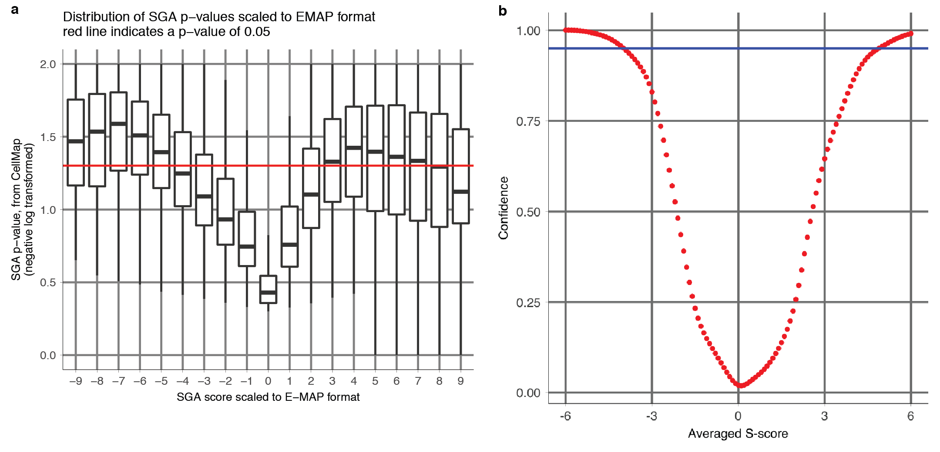

**Supplementary Figure 2 Comparison of definitions of high confidence S-scores used in our analysis**. **a,** Distribution ofthe SGA scores scaled to the E-MAP S-scores versus their corresponding published p-values from the CellMap8. **b,** Distribution of the E-MAP S-score averaged from all the individual replicates versus the confidence of the functional genetic interaction reproduced from Collins *et al*9.

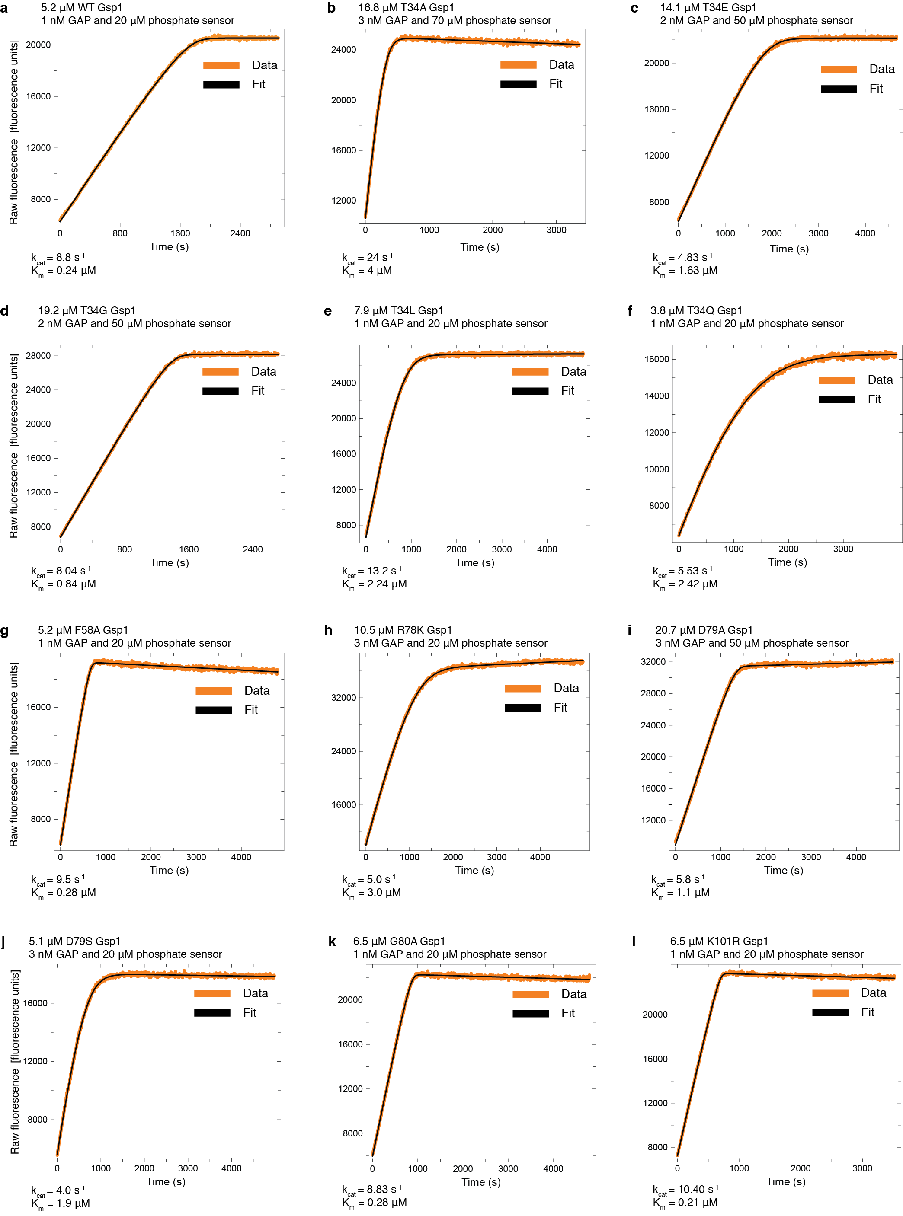

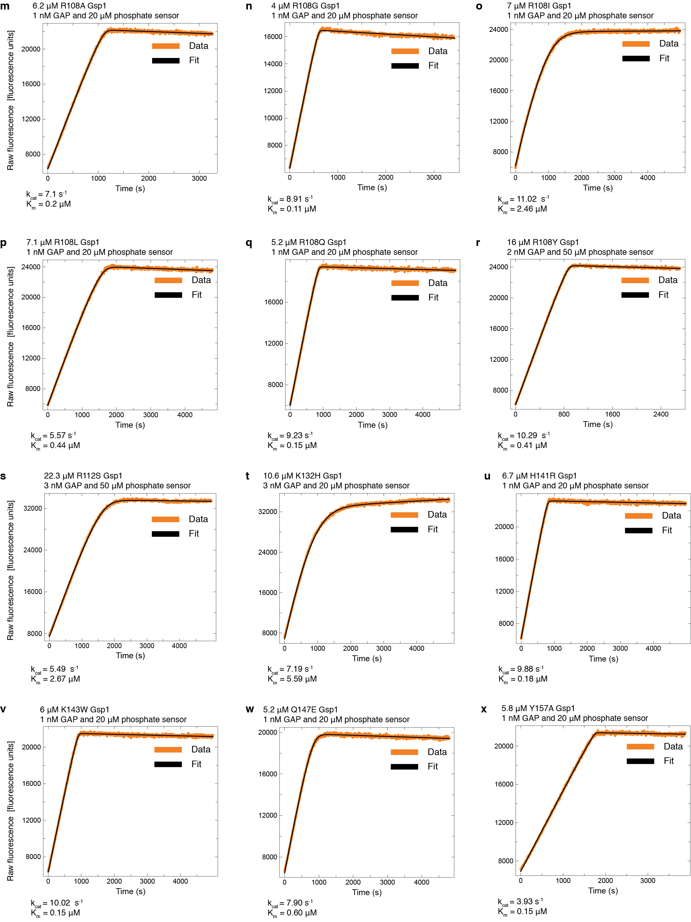

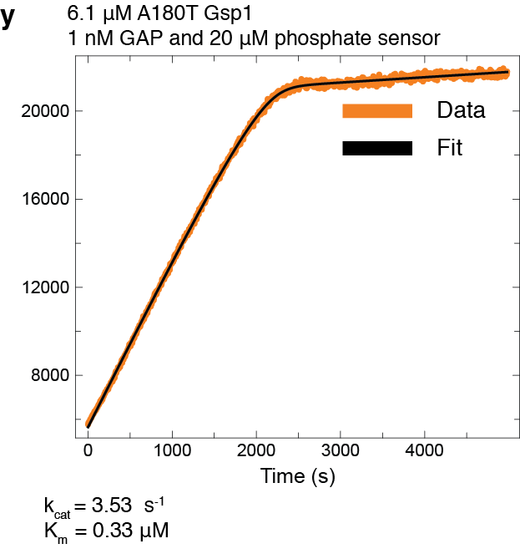

**Supplementary Figure 3 GAP-mediated GTP hydrolysis** **monitored as fluorescence increase upon binding of released free phosphate to a fluorescent phosphate sensor.** Curves were fit with the integrated Michaelis-Menten equation using the DELA software. Final Michaelis-Menten kinetic parameters (kcat and Km) for each Gsp1 mutant were calculated from three to nine individually fit curves as the ones shown in this figure. **a,** Wild type Gsp1, **b-y,** Gsp1 point mutants.

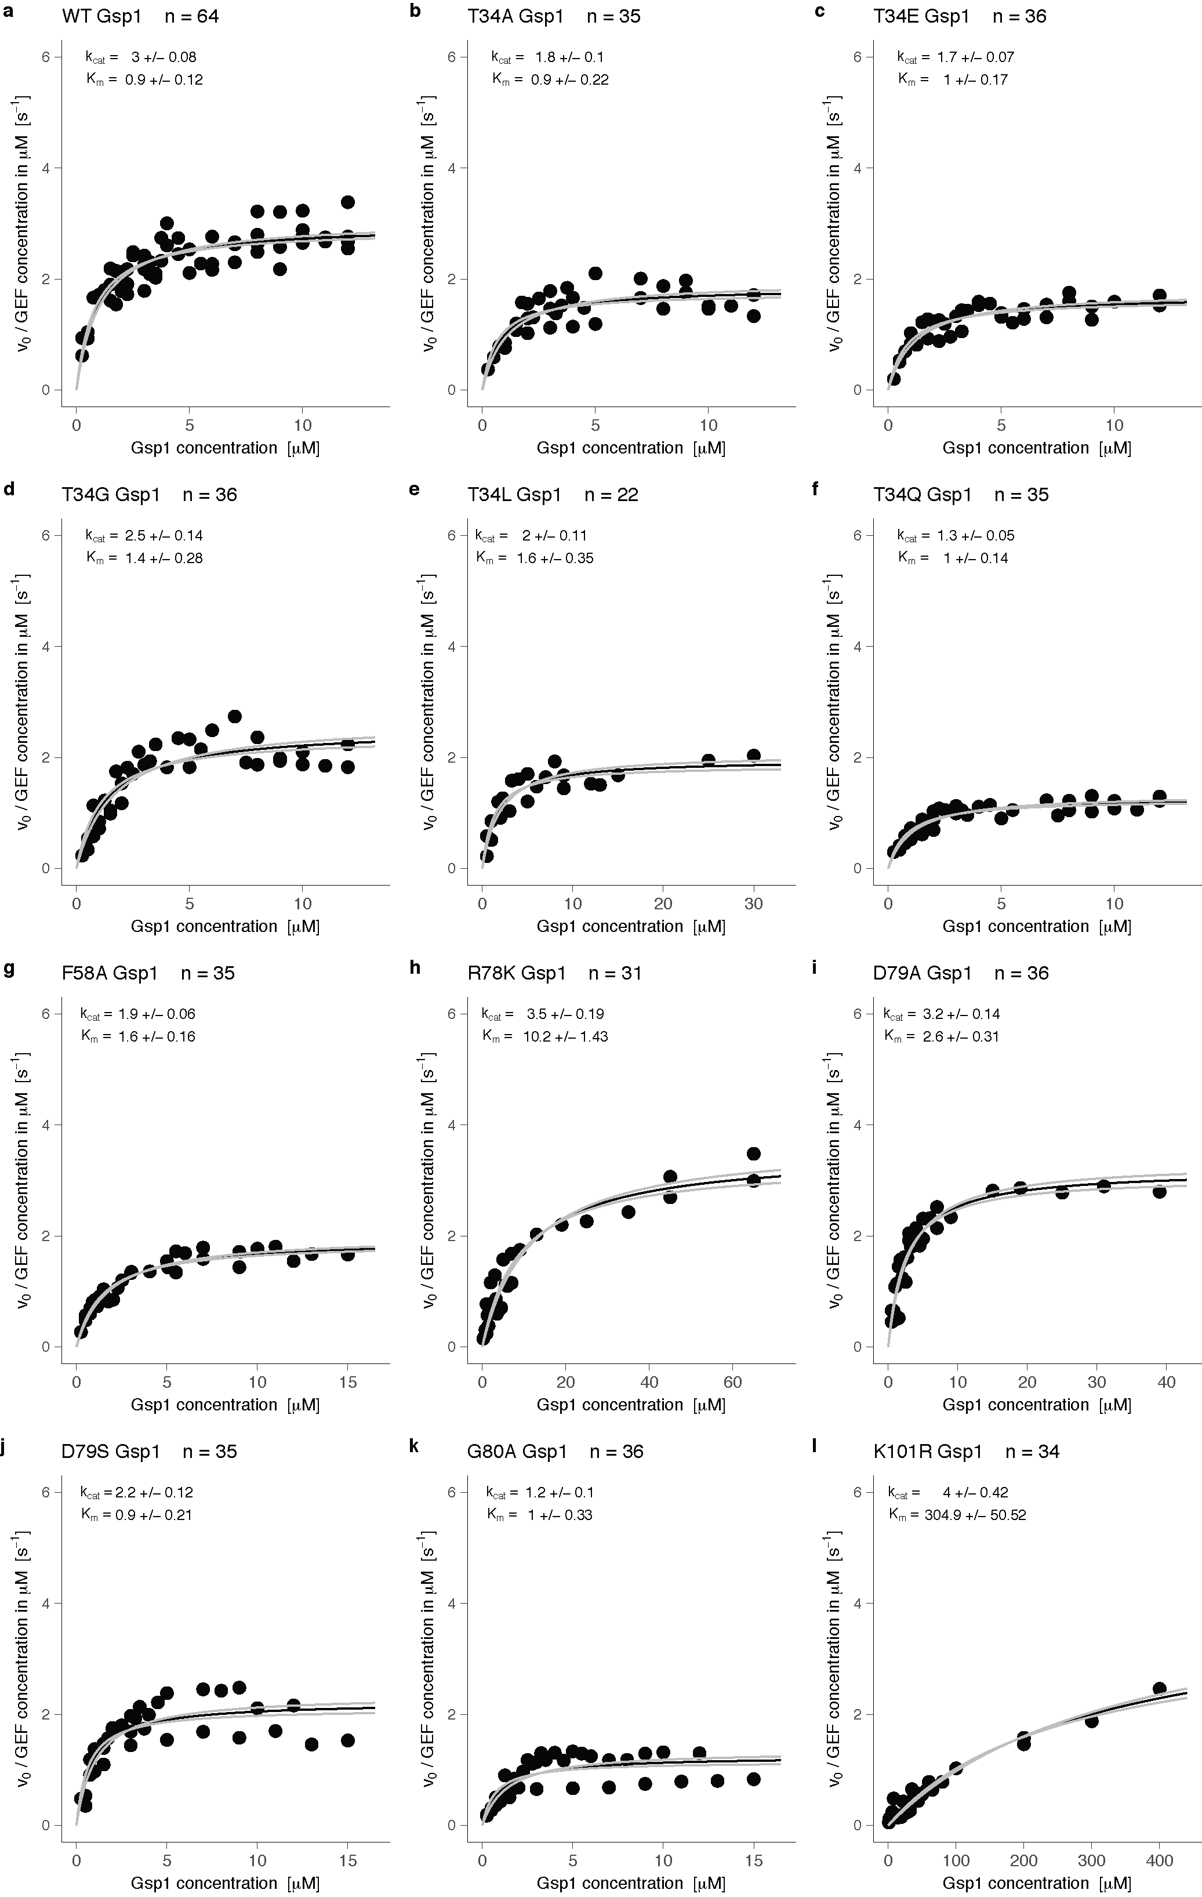

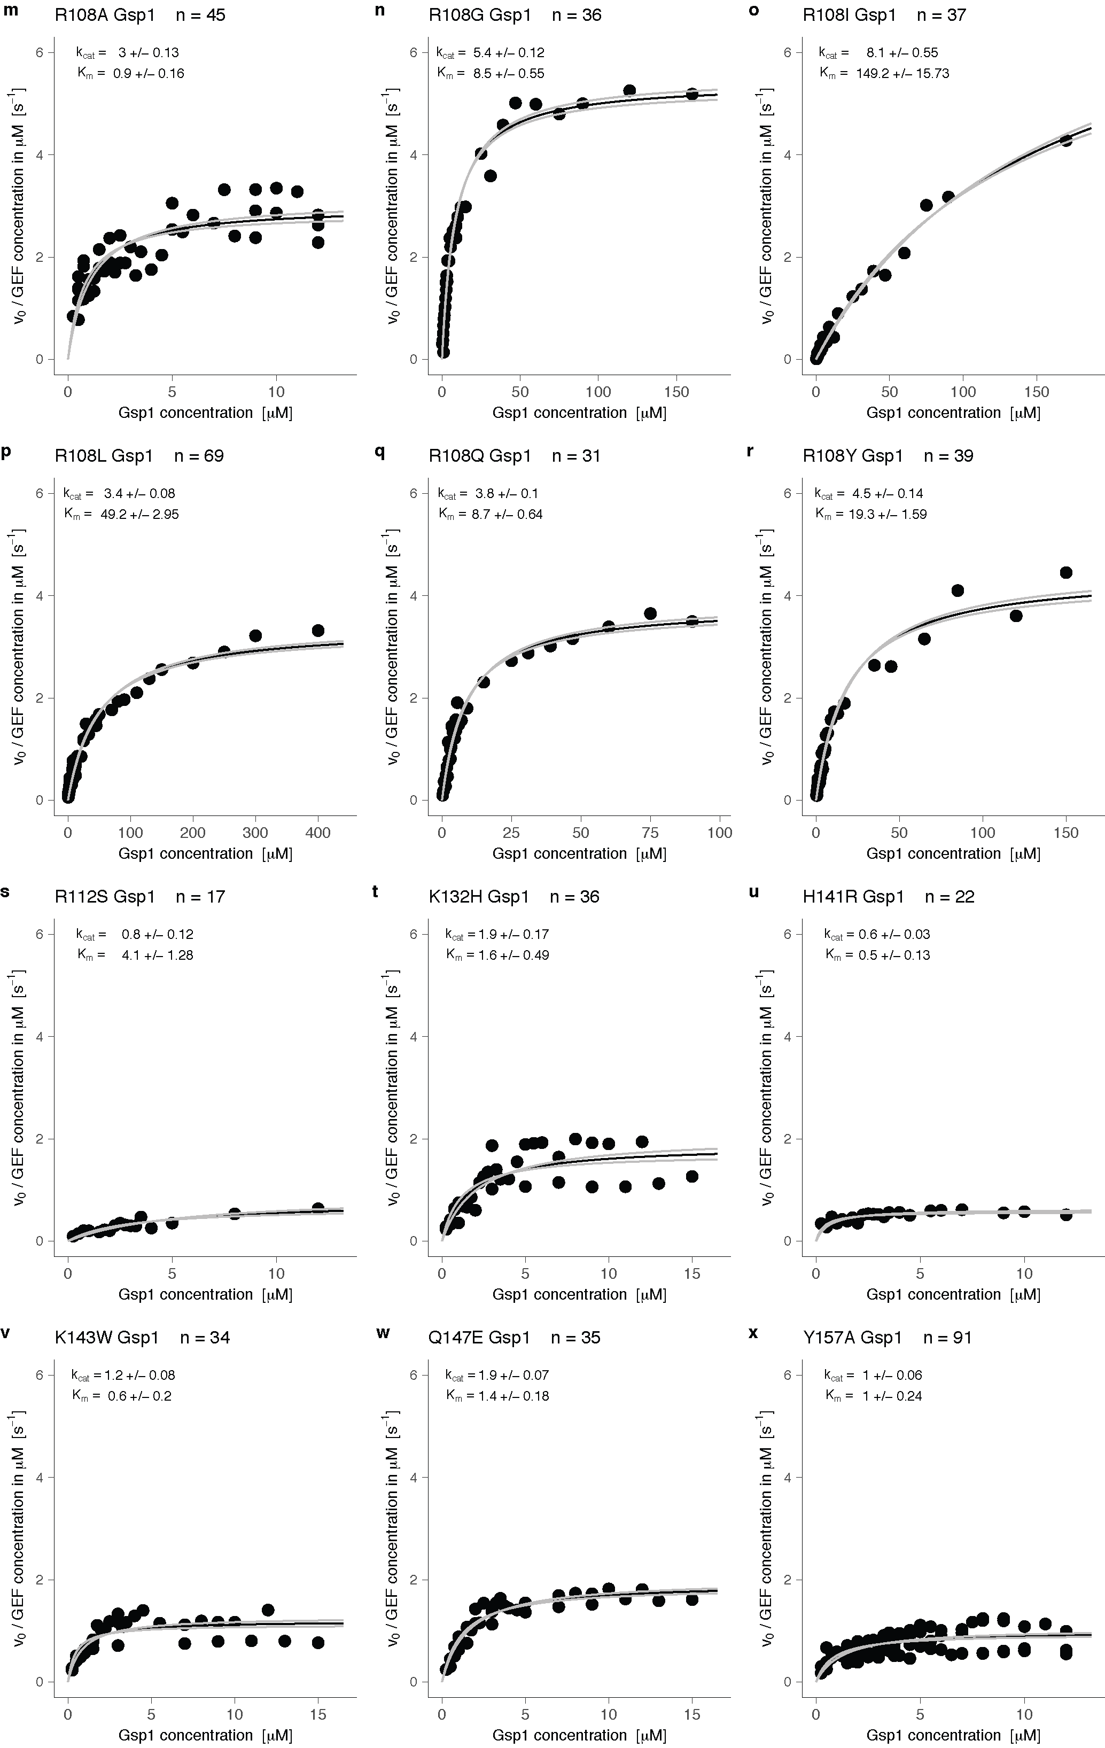

**Supplementary Figure 4 Michaelis-Menten plots for GEF-mediated nucleotide exchange**. Black line represents the Michaelis-Menten fit, and the gray lines represent the plus and minus one standard error of the fit. **a,** Wild type Gsp1. **b-y**, Gsp1 point mutants.

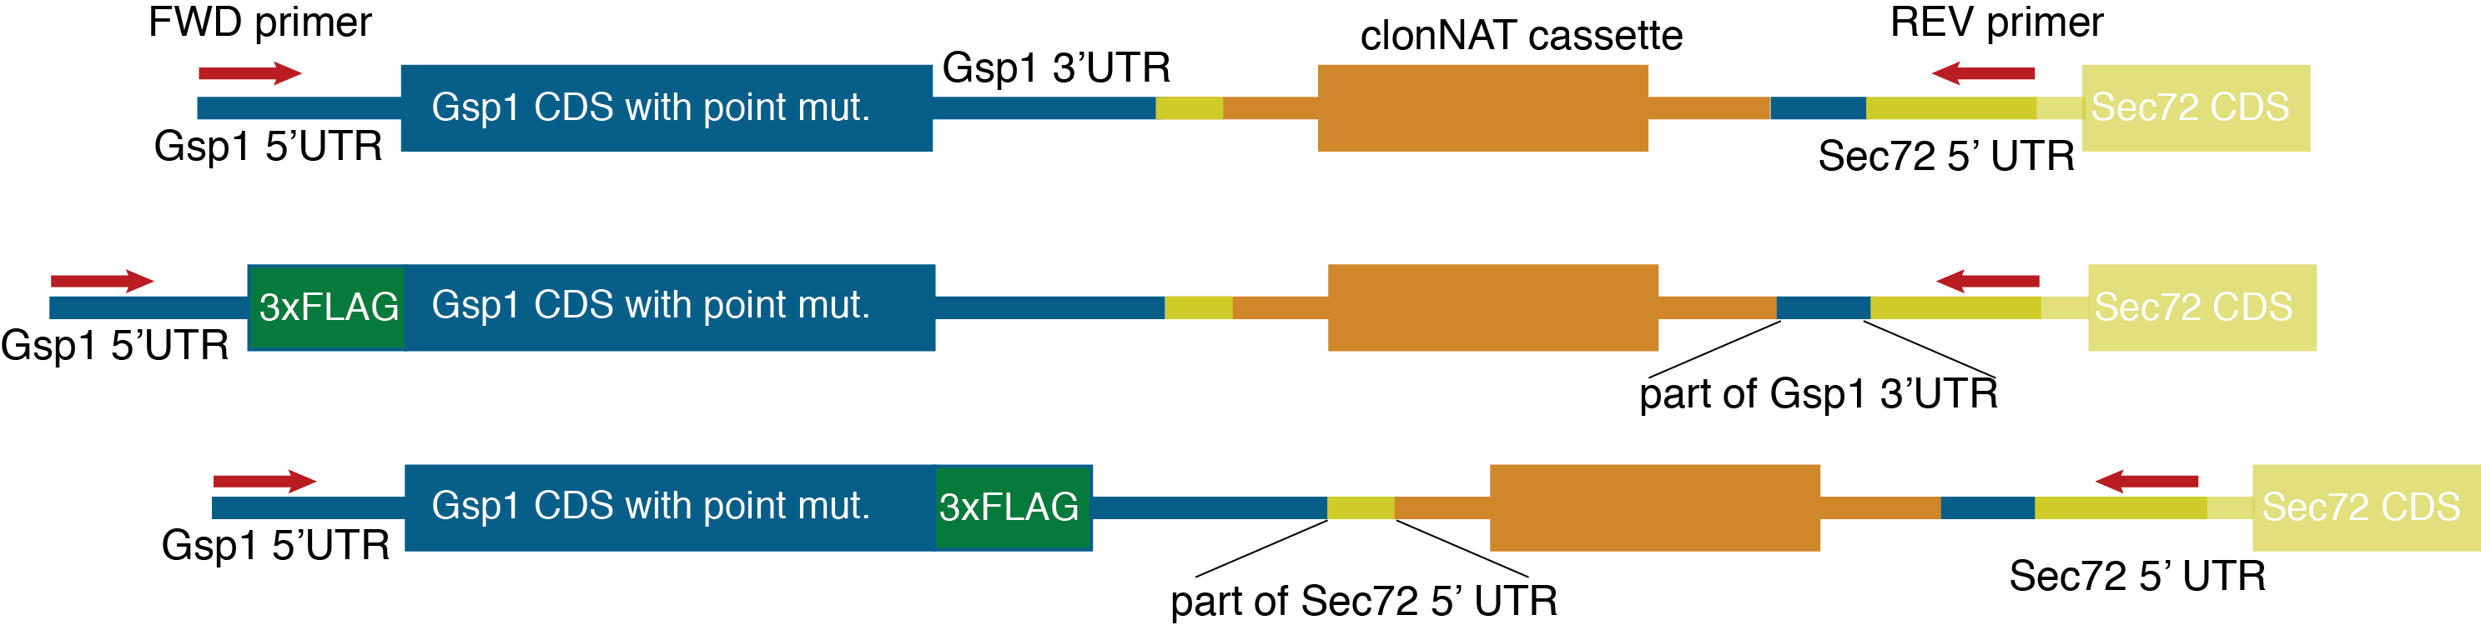

**Supplementary Figure 5 Schematic of genomically integrated *GSP1* constructs**. For E-MAP experiments, wild type or mutant GSP1 cassettes including the clonNAT resistance cassette were integrated into the MAT:α strain. For AP-MS the constructs also included either an amino- (N) terminal or a carboxy- (C) terminal 3xFLAG tag (M**DYKDHDGDYKDHDIDYKDDDDK**GGGGA and GGGGA**DYKDHDGDYKDHDIDYKDDDDK**, respectively).

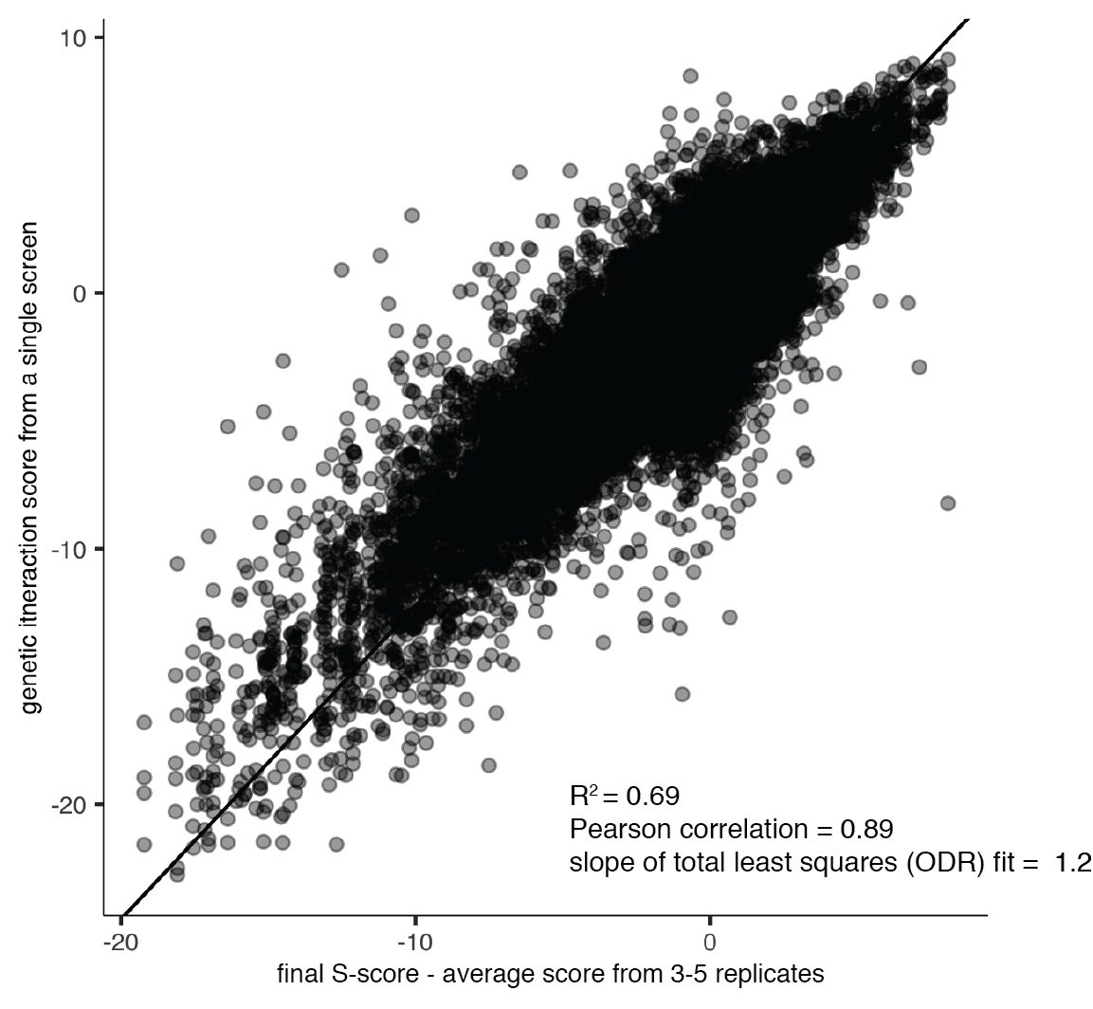

**Supplementary Figure 6 Reproducibility of *GSP1* point mutant E-MAP screens**, represented as a linear relationship between the genetic interaction S-score from a single E-MAP experiment and the final average S-score based on three or more replicates. The linear fit was calculated using the odregress function from the pracma R package.

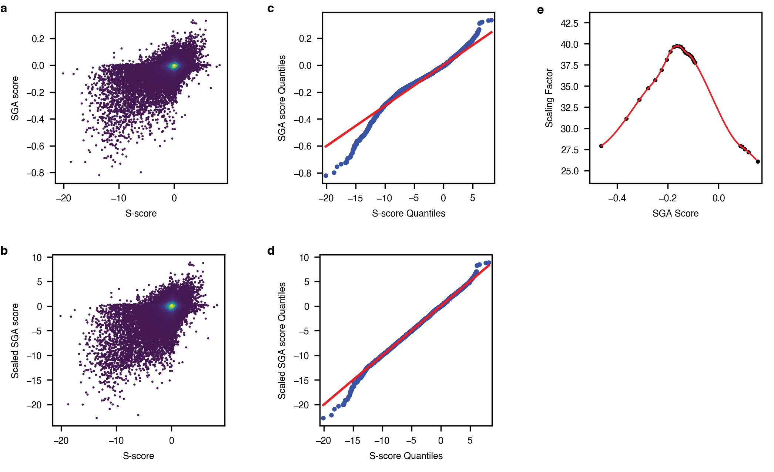

**Supplementary Figure 7 Non-linear scaling of SGA data from the Cell Map****8** **to E-MAP format.** **a,** Distribution of S-scores from the chromatin biology E-MAP dataset10 and the SGA score from the CellMap dataset. **b,** Distribution of S-scores from the chromatin biology E-MAP dataset and the *scaled* SGA score from the CellMap dataset. **c,** Quantile-quantile plot showing the distribution of genetic interaction scores from the CellMap and E-MAP chromatin biology datasets. **d,** Quantile-quantile plot showing the distribution of genetic interaction scores from the CellMap and E-MAP chromatin biology datasets after the CellMap dataset was scaled. **e,** The scaling function applied to the CellMap data. Red curve is the fitted spline of the scaling factors between the E-MAP S-scores and the SGA scores. Black dots represent the individual bins.

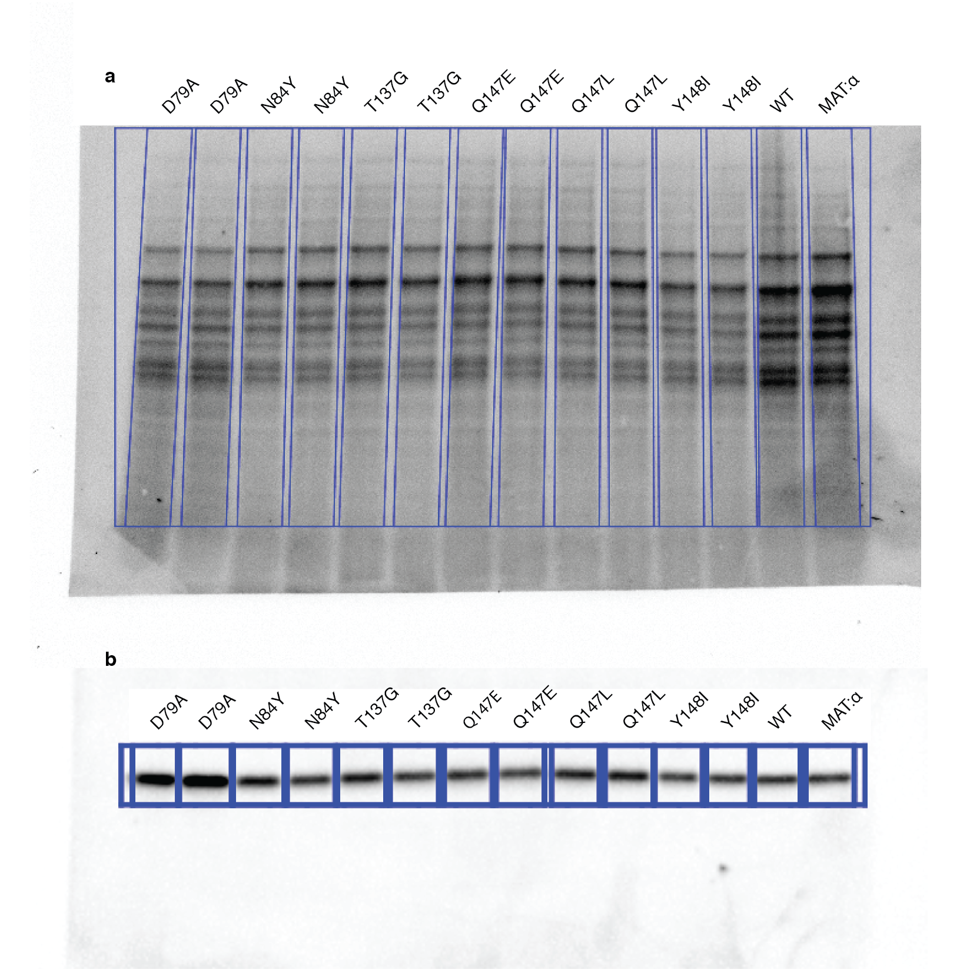

**Supplementary Figure 8 Example data for Gsp1 protein expression estimation by Western blot.** **a**, Total protein staining. **b**, Western blot of starting *S. cerevisiae* strain (MAT:α, see **Methods** for full strain description), wild type Gsp1 with clonNAT resistance marker (WT), and its mutants with anti-Ran antibody.

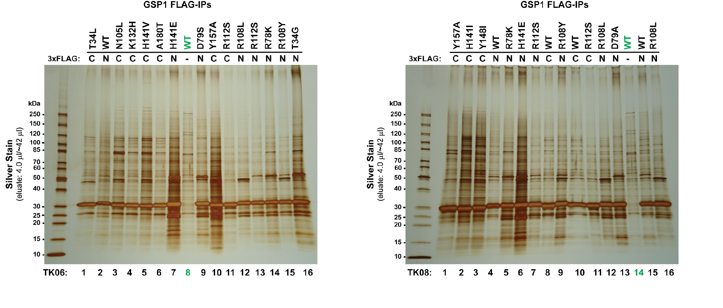

**Supplementary Figure 9 Silver stain gels after FLAG immunoprecipitation of amino- (N) or carboxy- (C) terminally 3xFLAG tagged genomically integrated Gsp1.** The strongest band at approximatelly 30 kDa corresponds to tagged Gsp1. Untagged wild type Gsp1 (lanes 8 and 14 in the left and right gel, respectively) were used as negative control for mass spectrometry analysis.

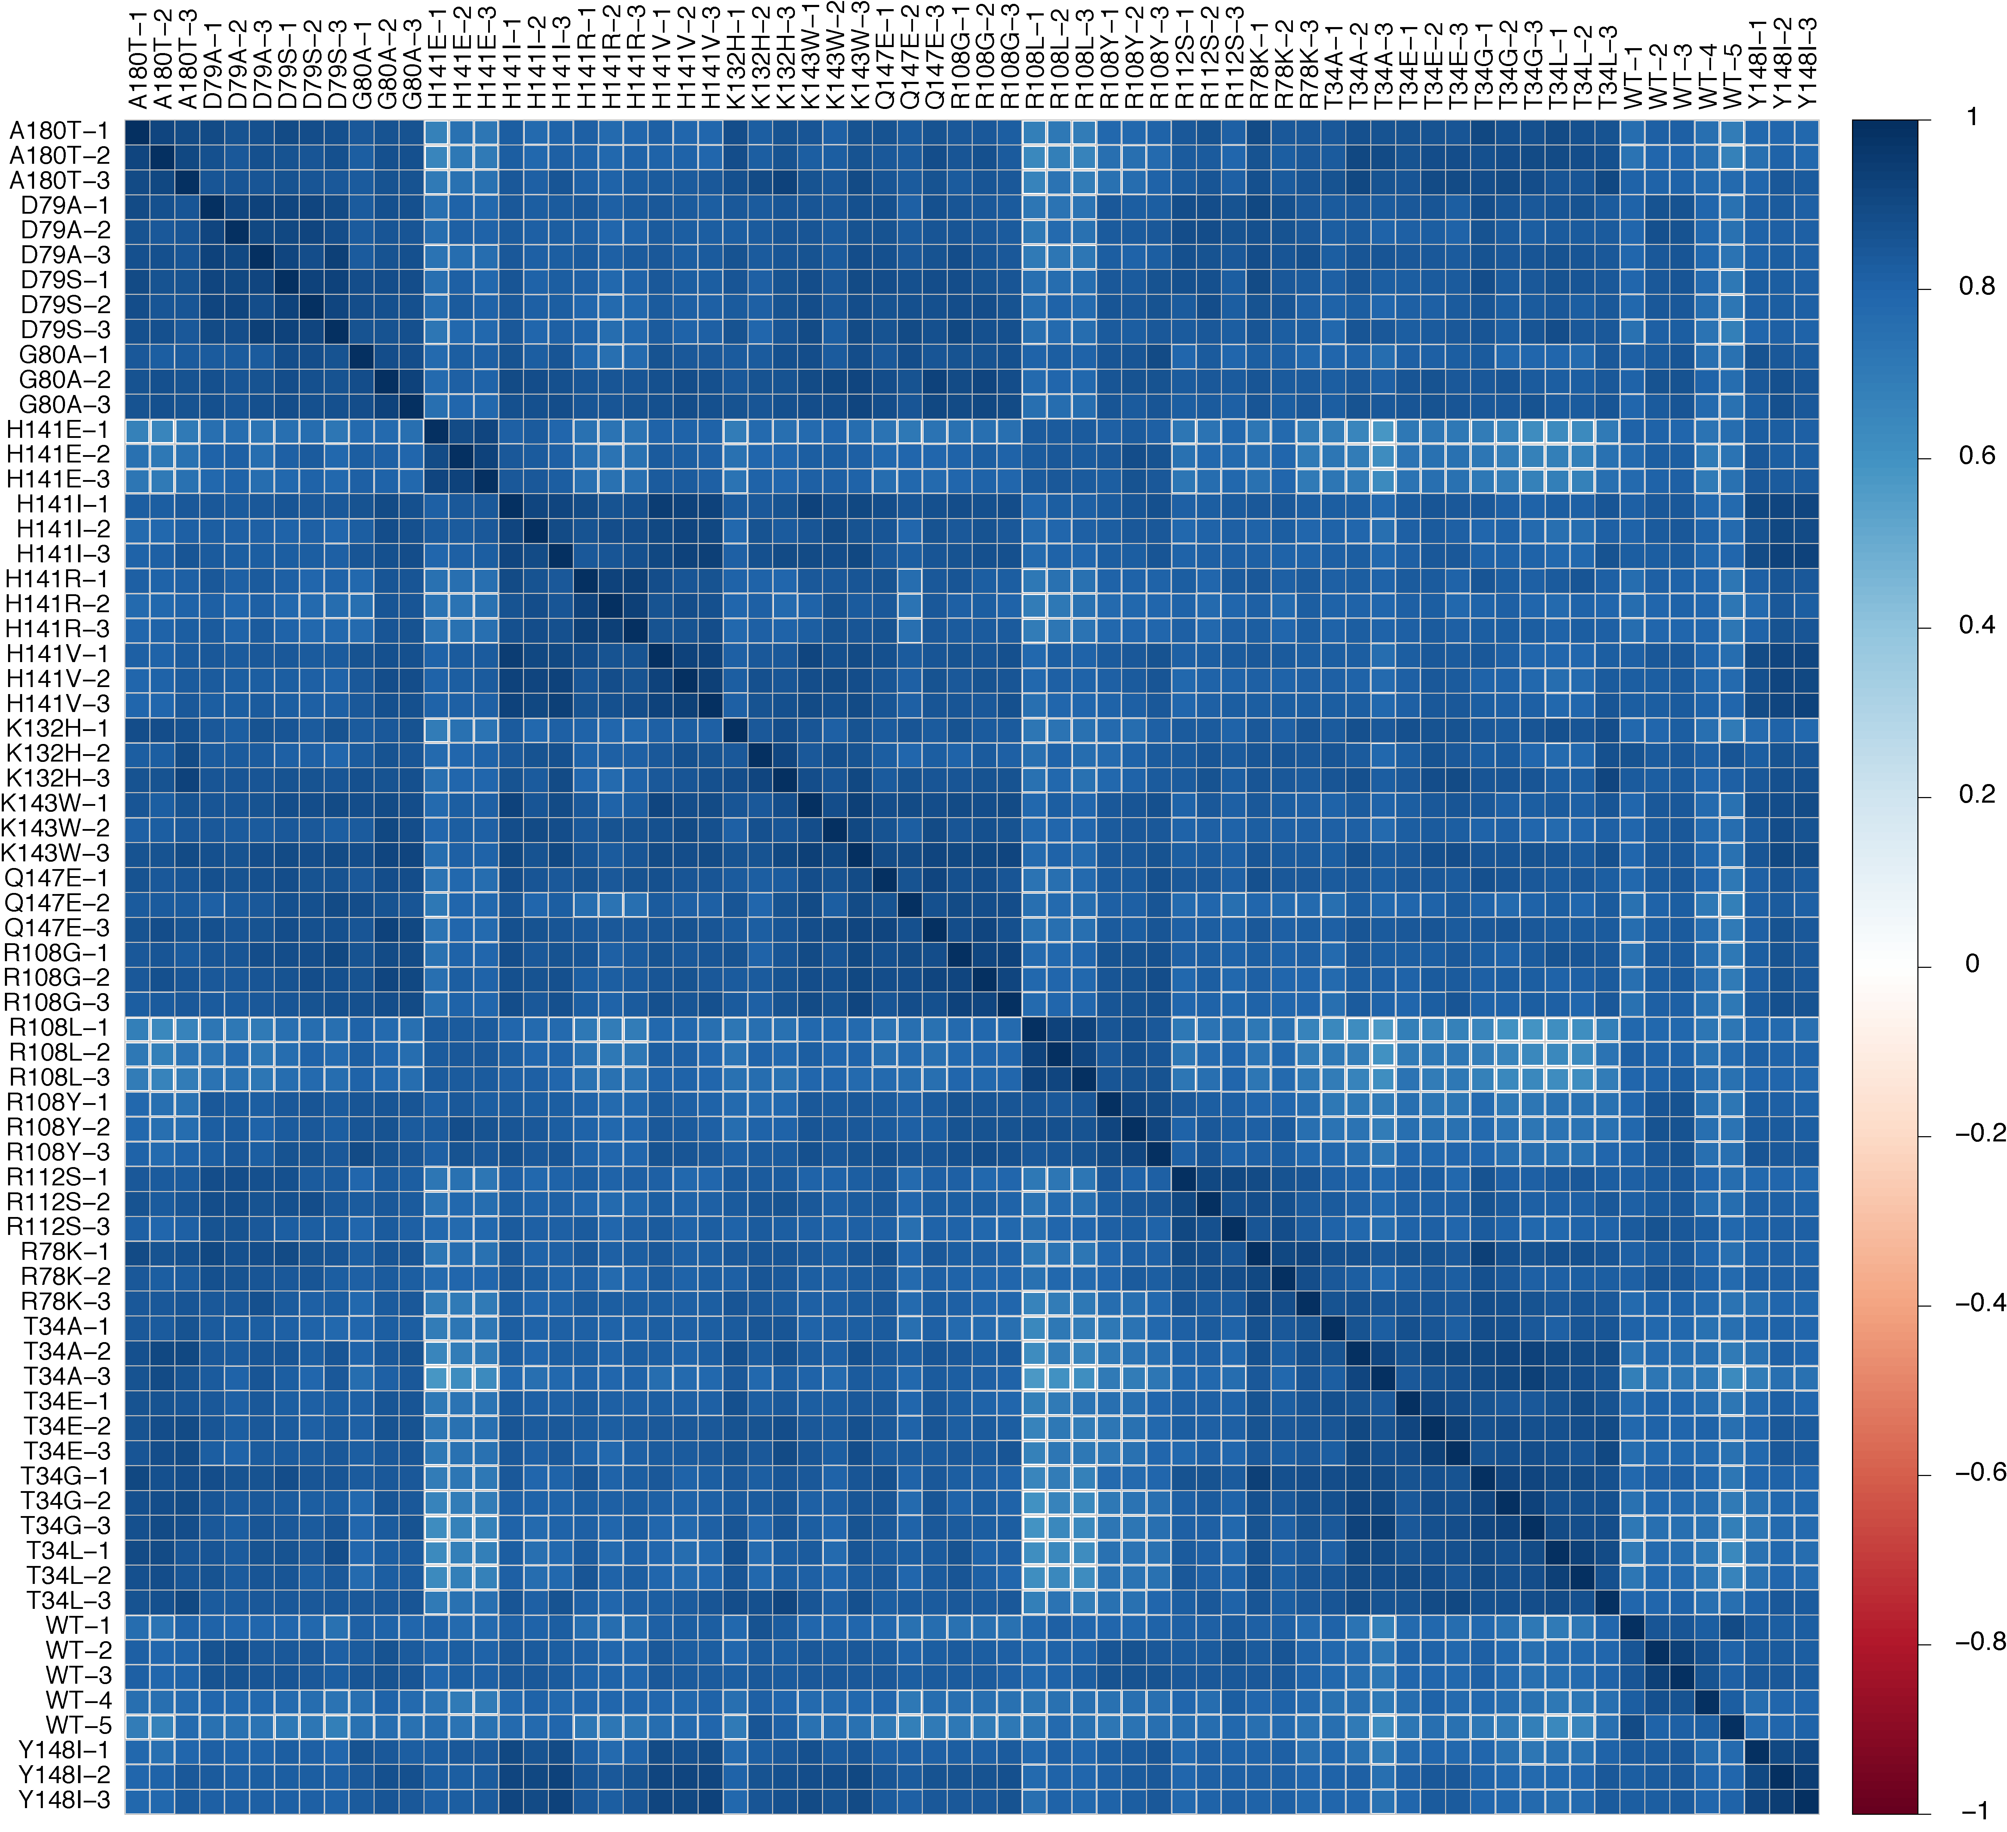

**Supplementary Figure 10 Clustering of individual AP-MS replicates** **based on correlations between protein abundance before the final scoring.** Data shown are for amino-terminally FLAG tagged wild type (WT) and Gsp1 mutants.

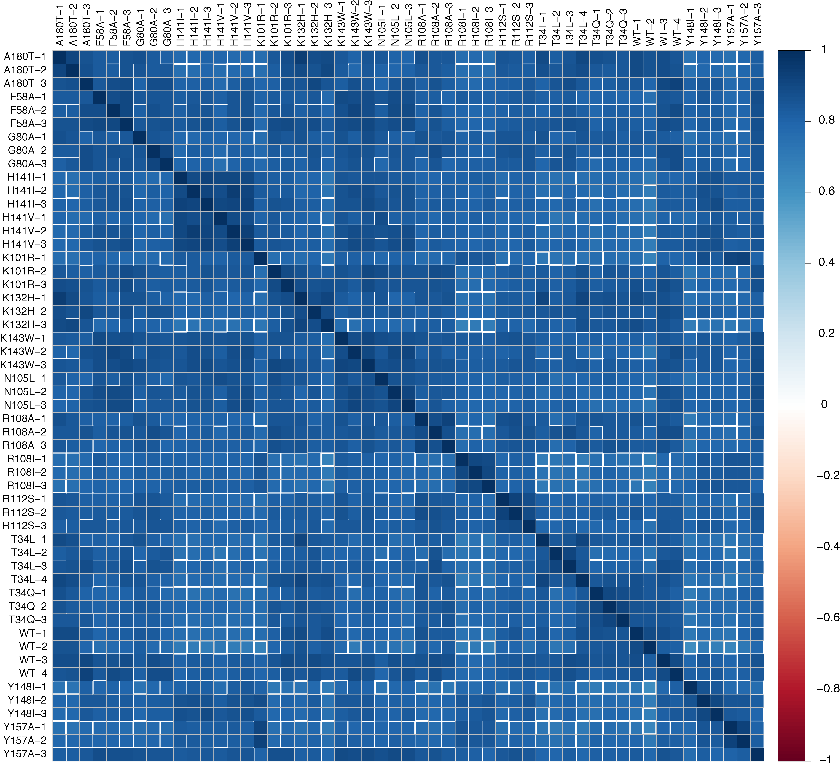

**Supplementary Figure 11 Clustering of individual AP-MS replicates** **based on correlations between protein abundance before the final scoring.** Data show are for carboxy-terminally FLAG tagged wild type (WT) and Gsp1 mutants.

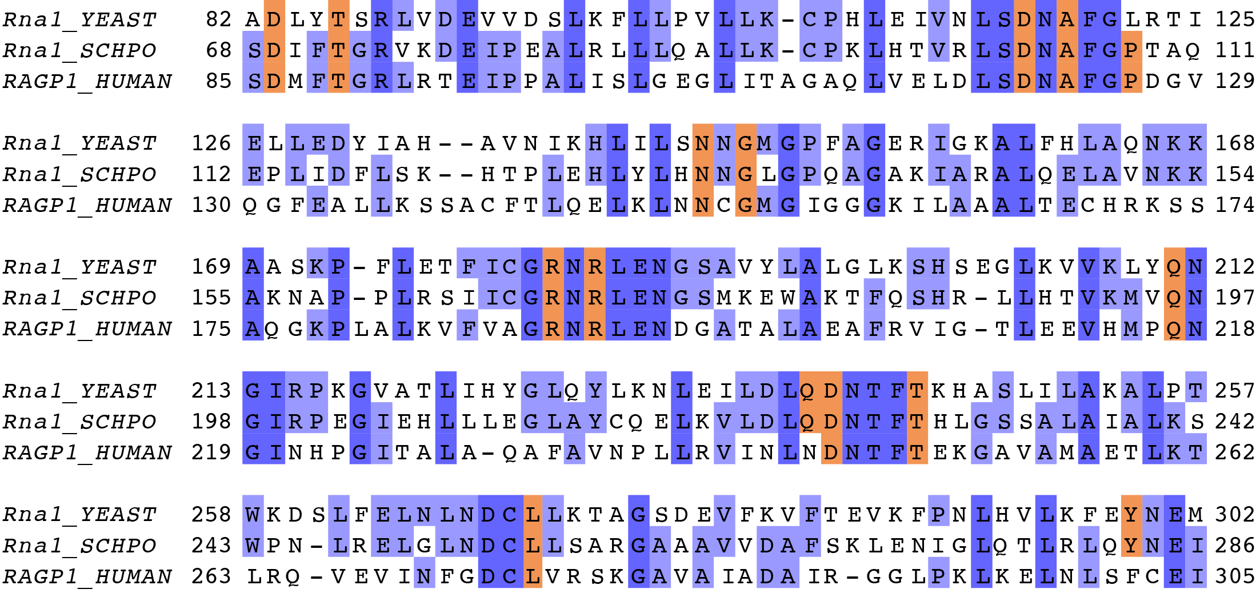

**Supplementary Figure 12 Multiple sequence alignment between Rna1 from *S. cerevisiae* (*Rna1_YEAST*) and *S. pombe* (*Rna1_SCHPO*), as well as human RanGAP (*RAGP1_HUMAN,*** excluding the C-terminal SUMO conjugation domainwhich is absent in Fungi).Overall sequence identity between *S. cerevisiae* and *S. pombe* Rna1 is 39%, with 53% sequence similarity.Interface core residues (based on the X-ray crystal structure between *S. pombe* Rna1 and mammalian Ran, PDB ID: 1k5d) are highlighted in orange. All interface core residues except Pro108 in *S. pombe* Rna1, which corresponds to Leu122 in *S. cerevisiae* Rna1, are conserved in sequence between *S. cerevisiae* and *S. pombe* Rna1.

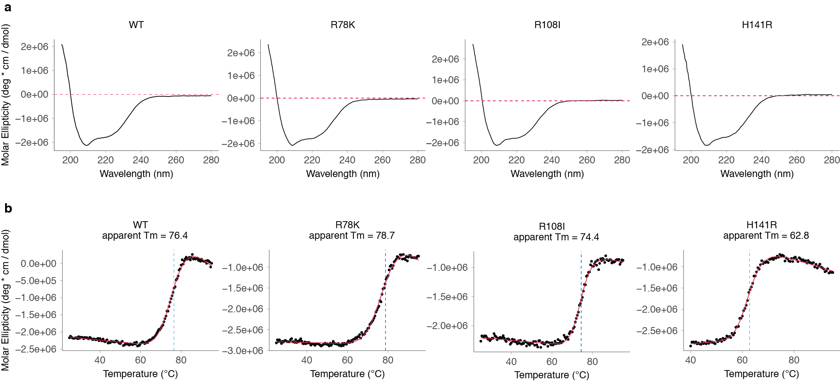

**Supplementary Figure 13 Circular dichroism (CD) data** for wild type (WT) Gsp1 and select mutants. **a,** CD spectra. **b,** Irreversible temperature melts.



**Supplementary Figure 14 HPLC reverse phase chromatograms** **of a GTP/GDP mix (top) and that of a purified and GTP loaded wild type Gsp1 (bottom).**

**Supplementary Figure 15 Accuracy estimation for determining the kinetic parameters of GAP-mediated GTP hydrolysis from individual time courses spanning [S] > Km to [S] << Km fit with an accurate solution of the integrated Michaelis Menten (IMM) equation.** Each time course was simulated using the experimentally determined parameters determined from the fitted IMM model, with added Gaussian noise similar to the experimental fluorescence signal noise. The deviation from the mean is plotted against a ratio of initial substrate (Gsp1:GTP) concentration [S] and the experimentally determined Km. Deviation from the mean is reported either as standard deviation or $RMSD= \sqrt{\frac{\sum{(simulation_param -experimental_param)^{2}}}{N}}$, where N = 100 simulations, and simulation_param and experimental_param are experimental and simulated kcat, Km, and kcat/Km, respectively. Here, simulated refers to the average of the fitted values for the simulated data sets.

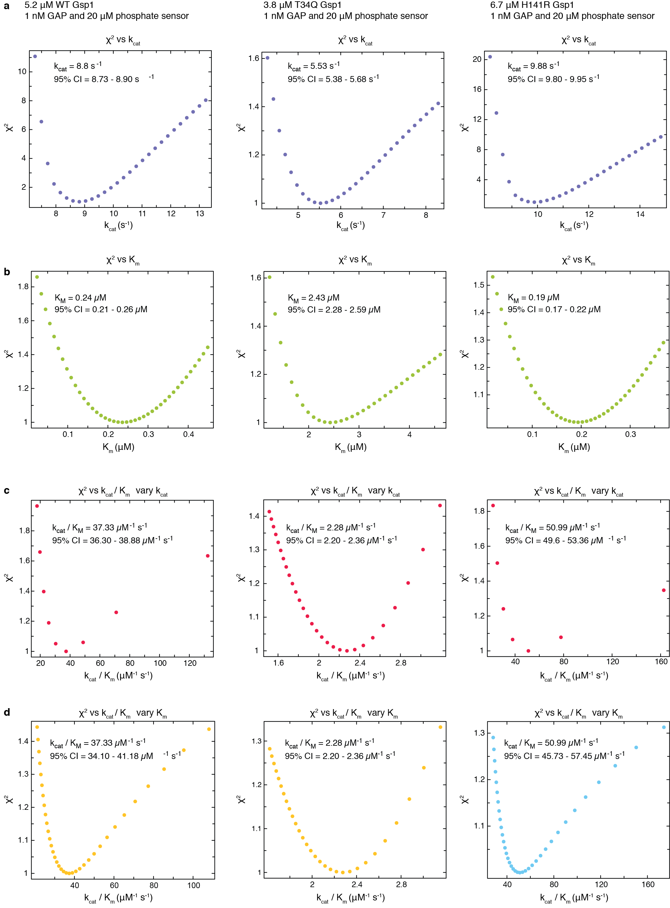

**Supplementary Figure 16 Estimated error around the maximum likelihood estimated values of the Michaelis-Menten parameters.** Plotted is the change in χ2 statistics as each of the parameters was fixed in gradual increments around the maximum likelihood value. The χ2 values are relative to the maximum likelihood values.

Error estimate analysis is shown for three of the Gsp1 variants: wild type Gsp1, the low efficiency Gsp1 T34Q mutant, and the high efficiency Gsp1 H141R mutant. 95% CI is the estimated 95% confidence interval for each value, based on the χ2 surface. **a**, Change of χ2 statistics as the kcat value is varied around the maximum likelihood value. **b**, Change of χ2 statistics as the Km value is varied around the maximum likelihood value. **c**, Change of χ2 statistics as the kcat/Km value is varied around the maximum likelihood value and the Km is kept fixed at the maximum likelihood value (kcat is varied). **d**, Change of χ2 statistics as the kcat/Km value is varied around the maximum likelihood value and the kcat is kept fixed at the maximum likelihood value (Km is varied).

# References

1 Klebe, C., Prinz, H., Wittinghofer, A. & Goody, R. S. The Kinetic Mechanism of Ran-Nucleotide Exchange Catalyzed by RCC1. *Biochemistry* **34**, 12543-12552, doi:10.1021/bi00039a008 (1995).

2 Gideon, P. *et al.* Mutational and kinetic analyses of the GTPase-activating protein (GAP)-p21 interaction: the C-terminal domain of GAP is not sufficient for full activity. *Molecular and Cellular Biology* **12**, 2050-2056, doi:10.1128/MCB.12.5.2050 (1992).

3 Brinkmann, T. *et al.* Rap-specific GTPase Activating Protein follows an Alternative Mechanism. *Journal of Biological Chemistry* **277**, 12525-12531, doi:10.1016/S1097-2765(01)80010-1 (2002).

4 Schnell, S. Validity of the Michaelis-Menten equation - steady-state or reactant stationary assumption: that is the question. *The FEBS journal* **281**, 464-472, doi:10.1023/A:1019139423811 (2013).

5 Hanson, S. M. & Schnell, S. Reactant Stationary Approximation in Enzyme Kinetics. *J Phys Chem A* **112**, 8654-8658, doi:10.1021/jp8026226 (2008).

6 Klebe, C., Bischoff, F. R., Ponstingl, H. & Wittinghofer, A. Interaction of the nuclear GTP-binding protein Ran with its regulatory proteins RCC1 and RanGAP1. *Biochemistry* **34**, 639-647 (1995).

7 Becker, J. *et al.* RNA1 encodes a GTPase-activating protein specific for Gsp1p, the Ran/TC4 homologue of Saccharomyces cerevisiae. *The Journal of biological chemistry* **270**, 11860-11865 (1995).

8 Costanzo, M. *et al.* A global genetic interaction network maps a wiring diagram of cellular function. *Science (New York, NY)* **353**, aaf1420-aaf1420, doi:10.1093/nar/gkt1076 (2016).

9 Collins, S. R., Schuldiner, M., Krogan, N. J. & Weissman, J. S. A strategy for extracting and analyzing large-scale quantitative epistatic interaction data. *Genome Biology* **7**, R63, doi:10.1186/gb-2006-7-7-r63 (2006).

10 Collins, S. R. *et al.* Functional dissection of protein complexes involved in yeast chromosome biology using a genetic interaction map. *Nature* **446**, 806-810, doi:10.1038/nature05649 (2007).